Mapping User Tasks to Application Architecture
Tyler Daniels
Southern New Hampshire University
CS-600
Professor Kardell
10-25-26

Mapping User Tasks to Application Architecture
For this assignment, I organized the customer request management system around the actions customers and staff need to perform. Customers need to describe an issue, review its progress, and maintain requests they have not submitted. Staff need to review requests, assign responsibility, update progress, and record completion. My diagram connects these goals to CRUD operations and task-based actions, then organizes the responsibilities into presentation, application, and data layers.
The CRUD operations support the basic management of request information. Creating a draft allows a customer to record a new issue. Reading includes viewing request details, searching or filtering requests, and checking their status. Updating allows customers to correct eligible draft information, while deleting removes an unneeded draft. These operations give customers control over the information they provide. The diagram assumes that customers can edit or delete only their own drafts. This rule would need stakeholder confirmation before implementation.
Task-based actions represent the broader goals behind a user’s interaction with the system. Submitting, assigning, and resolving a request involve business decisions as well as data changes. For example, submitting a request requires checking that the information is complete and that the request is in an eligible status. Assigning a request requires staff permission and a valid assignee. Resolving a request requires permission and an appropriate status transition. Each action can update the request and create a history entry, showing how one user task may involve several database operations.
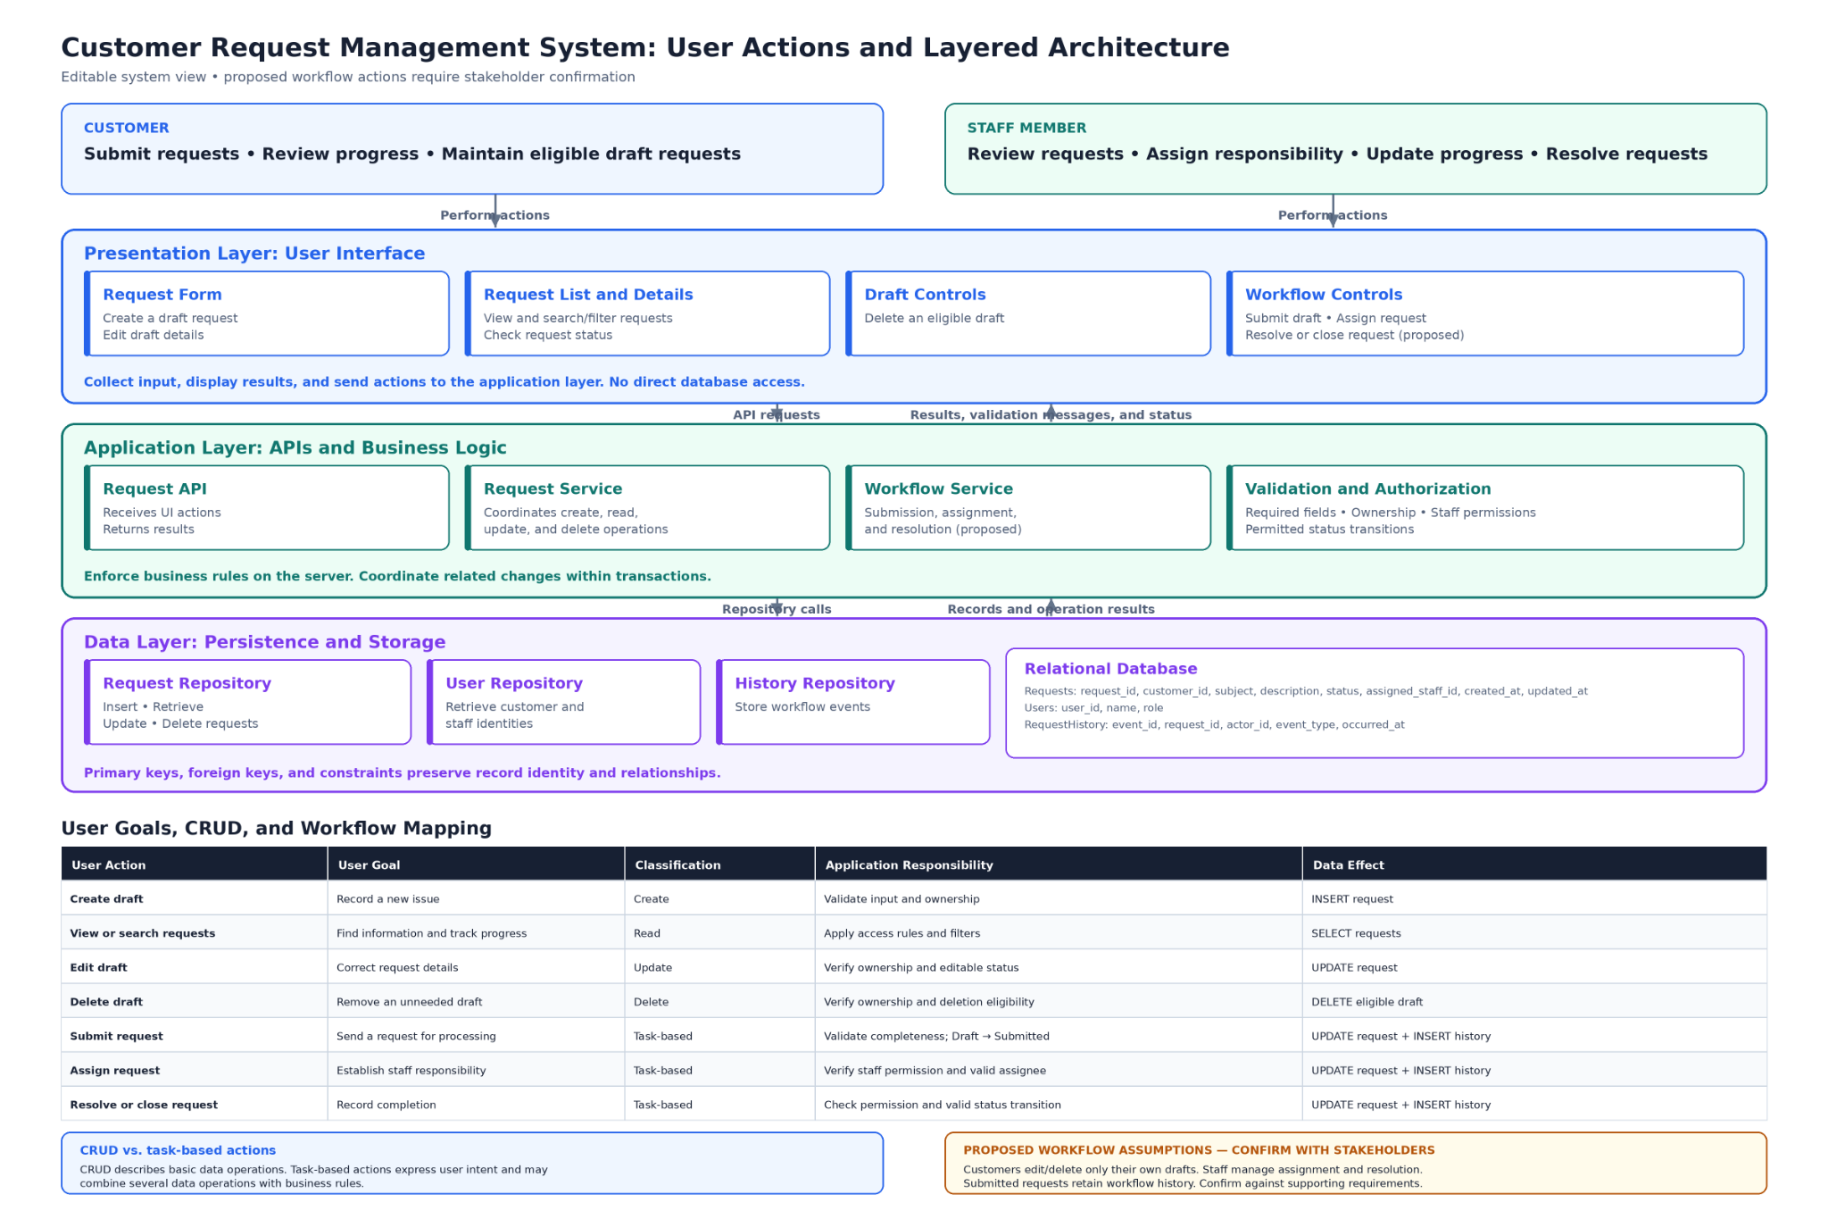
Figure 1. Customer request management system showing user actions, CRUD operations, and layered architecture
The presentation layer contains the interface elements customers and staff use directly. My diagram includes a request form, request list and details, draft controls, and workflow controls. The form supports creating and editing drafts, while the list allows users to find requests and review their progress. Workflow controls provide actions such as submission and assignment. This layer collects input, sends API requests, and displays results or validation messages. It does not access the database directly, which keeps interface responsibilities separate from data storage.
The application layer processes those API requests and applies the system’s business rules. The Request Service coordinates CRUD operations, while the Workflow Service handles submission, assignment, and resolution. Validation and authorization check required fields, request ownership, staff permissions, and permitted status changes. These checks belong on the server because interface restrictions alone cannot prevent unauthorized actions. Keeping the rules in this layer also provides a consistent way to enforce them if another interface is added later.
The data layer manages persistence through the Request Repository, User Repository, History Repository, and relational database. The Request Repository handles inserting, retrieving, updating, and deleting requests. The User Repository retrieves customer and staff identities, while the History Repository stores workflow events. The database contains Requests, Users, and RequestHistory records. Primary keys identify individual records, and foreign keys maintain their relationships. This organization supports retrieving request information while preserving its connection to the customer, assigned staff member, and recorded events.
The diagram’s arrows show how the layers cooperate to complete an action. When a customer submits a draft, the presentation layer sends the request to the application layer. The application checks ownership, completeness, and the current status before calling the repositories to save the changes. Updating the request and recording its submission should occur within one transaction so that both changes succeed or both are rolled back. The application then returns the result to the interface, where the customer sees the updated status or an explanation of what needs correction.
Separating these responsibilities makes the system easier to maintain and test. Changes to the request form would mainly affect the presentation layer, while changes to assignment rules would primarily affect the application layer. Database access remains organized within repositories. This structure allows developers to test interface behavior, business rules, and persistence separately before checking the complete workflow. It also provides a foundation for future additions, although scalability would still depend on implementation choices, database design, and performance testing.
Creating this diagram helped me understand the relationship between user goals and the operations needed to support them. Customers think about submitting an issue or checking its progress, while the system must translate those goals into permission checks, status changes, and stored records. The diagram also identifies assumptions that require stakeholder review, including draft-only customer editing, staff-controlled assignment and resolution, and retained history for submitted requests. In future development work, I would use this approach to clarify requirements and assign responsibilities before implementation begins.

